Press Release 10.10.19
Falls of Clyde-International Ltd
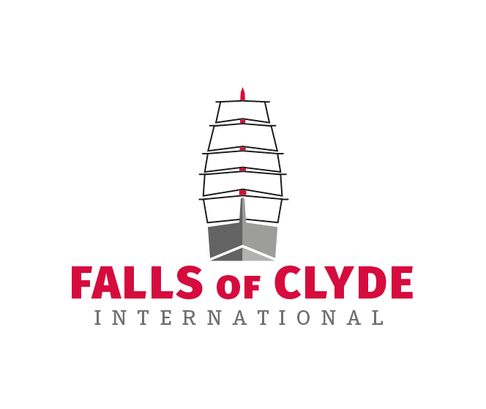
Falls of Clyde International are pleased to release details of our plans for the historic vessel ‘Falls of Clyde’, currently impounded by the state of Hawaii, Honolulu. Recent correspondence with DOT Harbors department recognises that our Scotland based campaign is a stand-alone group, separate in its identity from established local groups.
The ‘Falls of Clyde’ is to be repatriated to the U.K., as soon as a deal to share the removal costs from Honolulu harbour, can be reached with DOT Harbors Dept. This is to take place by means of a heavy lift vessel, once structural integrity has been clarified locally as suitable to transport.
The campaign has produced a brand sponsor plan that seeks to raise operational funds ($20m) through corporate branding, over a series of events en-route back to the U.K. and with branding on the ship itself. The plan is to hold local events where sponsors, supporters and the public can take part in welcoming events in each of the following ports, Honolulu, San Diego, Costa Rica. Fort Lauderdale, New York, Halifax N.S. and of course in Scotland, on arrival in the River Clyde, her birthplace. An estimated global reach for these events would be around 500m per event.
On arrival in Scotland, the vessel will be discharged into the River Clyde, then transferred to a semi-submersible barge to be moored in Victoria Harbour in Greenock, a mile or two from where she was built in Port Glasgow. (Malin Group)
A harbour side ‘Village’ will be proposed offering a repair and restoration site, side by side to a visitor centre, museum, genealogy centre, retail and catering units, creating up to 100 jobs. Additionally start up incubator units will be made available to local entrepreneurs to offer services to the anticipated 200k visitors to the site. The restoration of the ship is expected to cost in the region of $20m
This rebuild is expected to take up to three years, however once rebuilt her operational future will be secured through planned operations in the following sectors,
Education at Sea, Fairtrade Cargo, Sail Adventure Holidays and Cadet Training. Turnover from two of these sectors is anticipated at around £5m per annum, while a combination of two of these operations could increase that.
The ship will be built to comply with an emission free future, utilising carbon free technologies, through wind, solar, battery storage and possibly hydrogen power.

She will also play a role through her educational prospectus in the active clearing and collection for recycling of Ocean plastic waste for recycling (World Ocean Alliance).
As a community inspired business it is important to us that ordinary members of the public can benefit from her future activities, therefore we will offer to fund places on-board, to members of the local communities, in exchange for them volunteering in their local community for a period of up to 12 months. These opportunities will be offered to kids in both Hawaii and here in the U.K. We will be linking up with 3rd sector groups in both locations to continue, through community involvement the ships historic links to both sites. This initiative is aimed at offering life changing opportunities for travel, adventure and education, to those that may not have had the opportunity to do so.
We will also offer scholarships in Hawaii into education, seeking to share with the peoples of Hawaii the common bond from their joint association and heritage with the ship. We will work with educational institutions seeking to offer exchange programmes at college and university level, as well as linking up primary schools.
As the emission free cargo sector grows, we seek to trade in goods made in Hawaii and in the U.K., creating new markets but also taking those goods to wider global marketplaces.
We anticipate having a local presence in Honolulu and firmly believe that the ships future operations should include Hawaii as a regular place to visit, her second home.
Contact: David O’Neill
Phone: 07957 121918
Web: www.foci.scot

